Install the File Share-GUI Application from GitHub including dependencies

Step 01: Ensure python has been installed on the local machine
Check to see if python is installed on the machine:
Open Command Prompt from the Windows Start Menu:
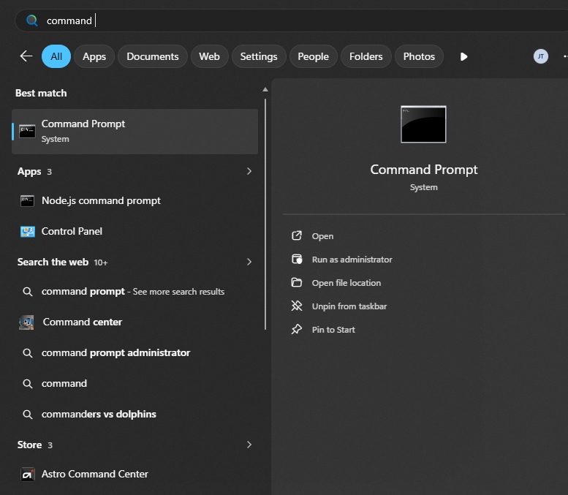
At the command line interface (CLI) type: py –version
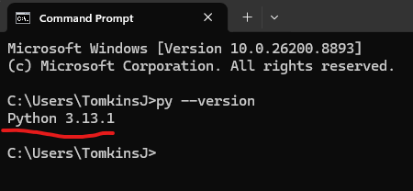
You should see Python and version specified, similar to: Python 3.13.1
If it is not found, open a new ticket with Employee Service Portal (ESP) to request the distribution via the company portal.
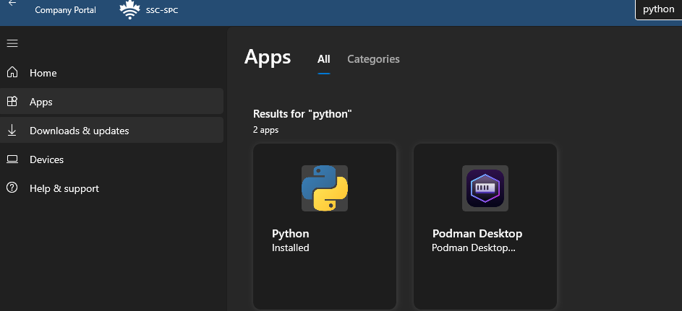

Step 02: Navigate to the downloaded application
Ensure you have downloaded the application from GitHub to C:\FileShare-GUI
Type: cd C:\FileShare-GUI
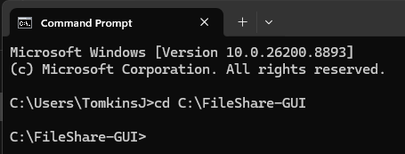

Step 03: Activate or Create a virtual environment
A virtual environment is an isolated directory on our computer that contains its own specific Python interpreter, python libraries and scripts.

Create the virtual environment (this will create a folder within the project directory):
Type: py -m venv FileShare-GUI
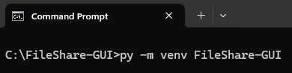
Activate the environment (activating the environment from within the folder structure):
Type: FileShare-GUI\Scripts\activate
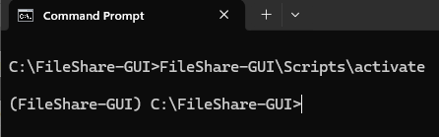
Notice the prefix in Red: (FileShare-GUI) C:\FileShare-GUI>
This notation “(FileShare-GUI)” indicates the environment is active and anything we install will be isolated from the remainder of the computer. Also, we must activate the environment to start the application and this will be a highly repeated step later on.

Step 04: Install Application Dependencies
Check to see if you’re in the correct folder by typing “dir” which displays all the files and folders of the application.
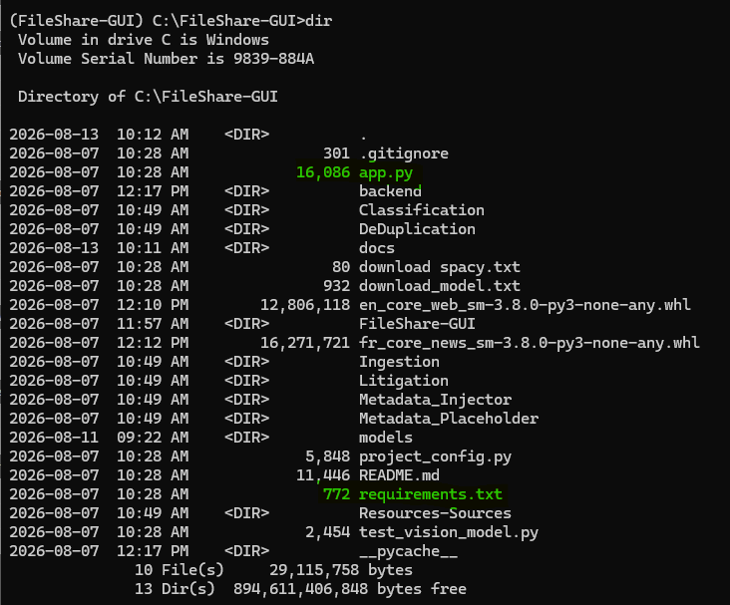
This list includes all the files and folders of the application. For our purposes, there are two important files. To start the application, later we will be using py app.py but for now we must install all the necessary application dependencies.
You should see the requirements.txt file.
To install the dependencies, Type: py -m pip install -r requirements.txt
DO NOT RUN or ATTEMPT TO UPDATE ANY LIBRARIES. Each python library was evaluated to ensure that no vulnerabilities. Updating libraries could introduce vulnerabilities or cause incompatible libraries.

If everything installs successfully, we need to install one more dependency or library called Spacy for language detection.
Navigate to: English · spaCy Models Documentation and download the file highlighted in yellow.
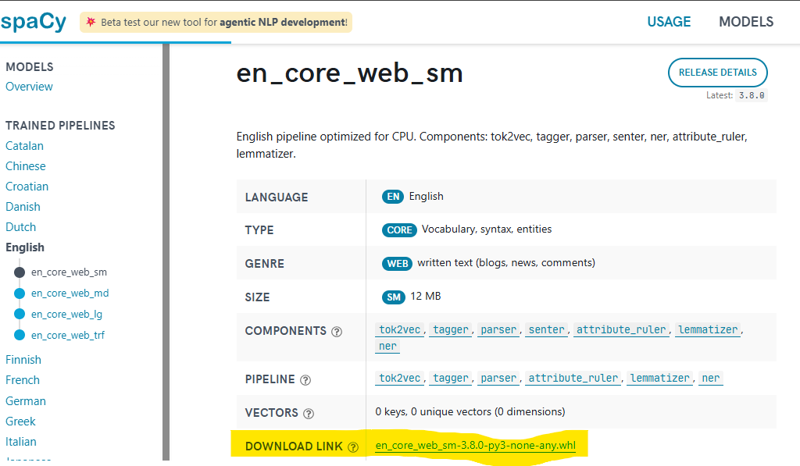
Navigate to: French · spaCy Models Documentation and download the file highlighted in yellow.
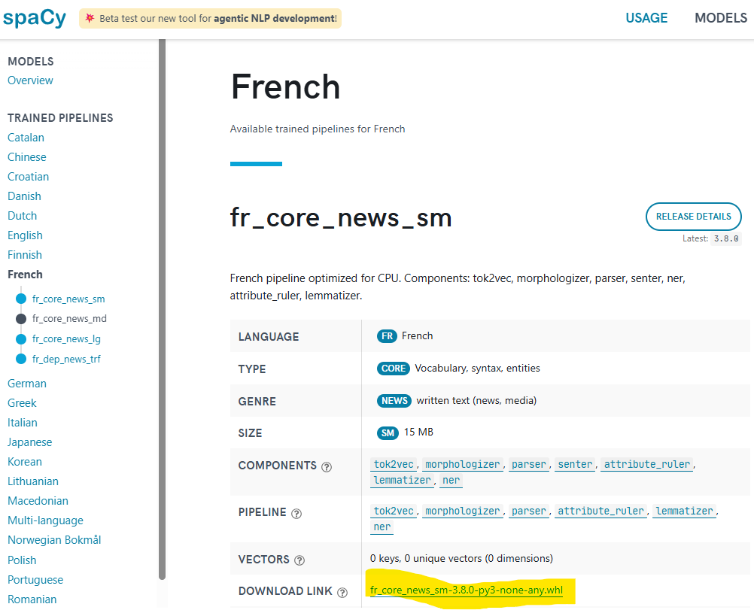

Move both en_core_web_sm-3.8.0-py3-none-any.whl and fr_core_news_sm-3.8.0-py3-none-any.whl from the Downloads to the Project Directory or C:\FileShare-GUI.

Switch to the Command Prompt or CLI and install both Spacy libraries with the following commands.
Ensure the following before executing the command:
- Environment is activated: (FileShare-GUI)
- Project Directory: C:\FileShare-GUI
- Bash Command: pip install en_core_web_sm-3.8.0-py3-none-any.whl

Result:
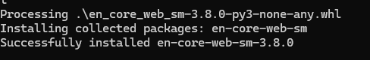
Repeat for the French: pip install fr_core_news_sm-3.8.0-py3-none-any.whl
Result:
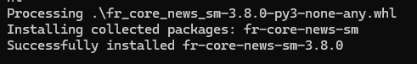

Step 05: Run the application
Type: py app.py
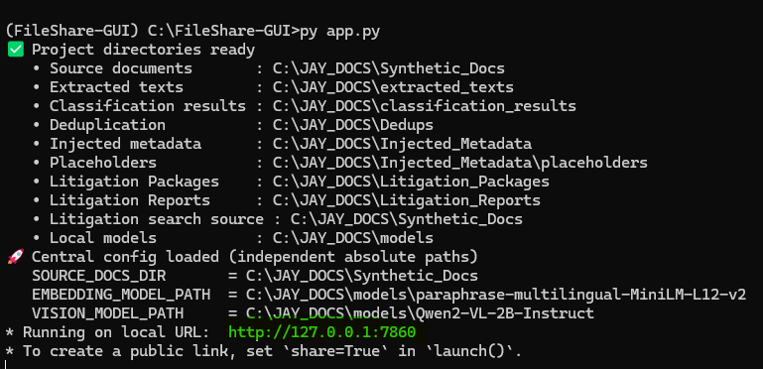
Hold Ctrl + Mouse Click on http://127.0.0.1:7860 or type the address into your browser and the application should open. At this point the application should open/start without error. To end or stop press Ctrl + C.

Step 06: Download the Open-Source models for local compute.
We have two models to download from HuggingFace. We have the vision model to interpret images and the embedding model used for classification and search.
First, we must create a folder in our project directory to save the models locally. In Windows Explorer, create a folder named models.
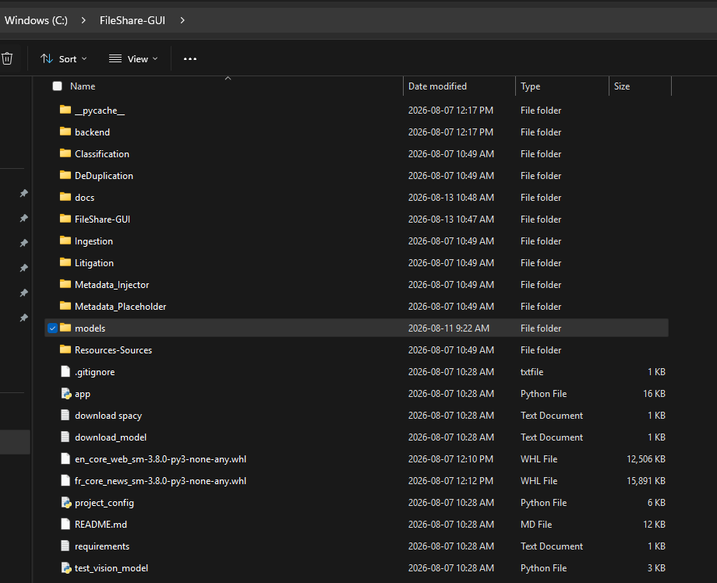
Second, return to the Command Prompt or CLI and change directory into the folder “models”.
Type: cd models
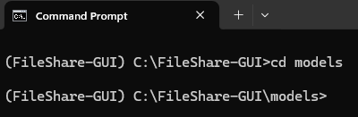
Execute the following commands one at a time to download the models to: (FileShare-GUI) C:\FileShare-GUI\models

git -c http.sslVerify=false clone https://huggingface.co/Qwen/Qwen2-VL-2B-Instruct
git -c http.sslVerify=false clone https://huggingface.co/sentence-transformers/paraphrase-multilingual-MiniLM-L12-v2
git -c http.sslVerify=false clone https://huggingface.co/Qwen/Qwen3-Embedding-0.6B

You have now completed the installation of FileShare-GUI Application and all of the necessary dependencies. You can run the application by typing: py app.py

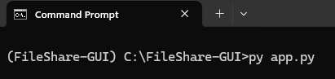

Next, we must configure the project_config.py file for all absolute paths related to the application. Each path is necessary for source files, cloning files, adding files, searching files and project directory location.

